Three-phase power systems

Split-phase power systems achieve their high conductor efficiency and low safety risk by splitting up the total voltage into lesser parts and powering multiple loads at those lesser voltages, while drawing currents at levels typical of a full-voltage system. This technique, by the way, works just as well for DC power systems as it does for single-phase AC systems. Such systems are usually referred to as three-wire systems rather than split-phasebecause “phase” is a concept restricted to AC.
But we know from our experience with vectors and complex numbers that AC voltages don't always add up as we think they would if they are out of phase with each other. This principle, applied to power systems, can be put to use to make power systems with even greater conductor efficiencies and lower shock hazard than with split-phase.
Suppose that we had two sources of AC voltage connected in series just like the split-phase system we saw before, except that each voltage source was 120º out of phase with the other: (Figure below)
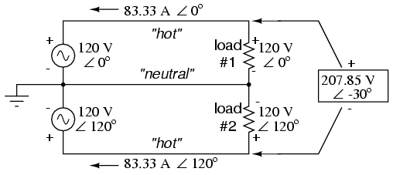
Pair of 120 Vac sources phased 120º, similar to split-phase.
Since each voltage source is 120 volts, and each load resistor is connected directly in parallel with its respective source, the voltage across each loadmust be 120 volts as well. Given load currents of 83.33 amps, each load must still be dissipating 10 kilowatts of power. However, voltage between the two “hot” wires is not 240 volts (120 ∠ 0º - 120 ∠ 180º) because the phase difference between the two sources is not 180º. Instead, the voltage is:
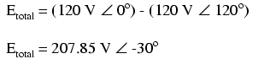
Nominally, we say that the voltage between “hot” conductors is 208 volts (rounding up), and thus the power system voltage is designated as 120/208.
If we calculate the current through the “neutral” conductor, we find that it is not zero, even with balanced load resistances. Kirchhoff's Current Law tells us that the currents entering and exiting the node between the two loads must be zero: (Figure below)
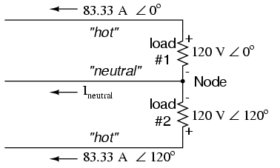
Neutral wire carries a current in the case of a pair of 120º phased sources.
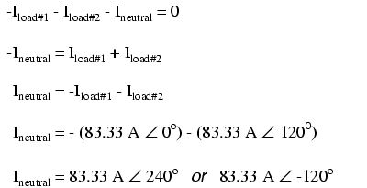
So, we find that the “neutral” wire is carrying a full 83.33 amps, just like each “hot” wire.
Note that we are still conveying 20 kW of total power to the two loads, with each load's “hot” wire carrying 83.33 amps as before. With the same amount of current through each “hot” wire, we must use the same gage copper conductors, so we haven't reduced system cost over the split-phase 120/240 system. However, we have realized a gain in safety, because the overall voltage between the two “hot” conductors is 32 volts lower than it was in the split-phase system (208 volts instead of 240 volts).
The fact that the neutral wire is carrying 83.33 amps of current raises an interesting possibility: since its carrying current anyway, why not use that third wire as another “hot” conductor, powering another load resistor with a third 120 volt source having a phase angle of 240º? That way, we could transmitmore power (another 10 kW) without having to add any more conductors. Let's see how this might look: (Figure below)
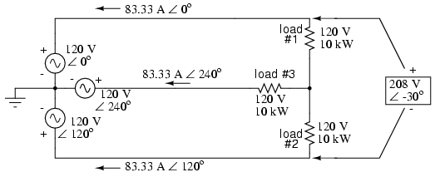
With a third load phased 120º to the other two, the currents are the same as for two loads.
A full mathematical analysis of all the voltages and currents in this circuit would necessitate the use of a network theorem, the easiest being the Superposition Theorem. I'll spare you the long, drawn-out calculations because you should be able to intuitively understand that the three voltage sources at three different phase angles will deliver 120 volts each to a balanced triad of load resistors. For proof of this, we can use SPICE to do the math for us: (Figure below, SPICE listing: 120/208 polyphase power system)
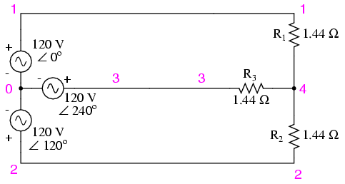
SPICE circuit: Three 3-Φ loads phased at 120º.
120/208 polyphase power system
v1 1 0 ac 120 0 sin
v2 2 0 ac 120 120 sin
v3 3 0 ac 120 240 sin
r1 1 4 1.44
r2 2 4 1.44
r3 3 4 1.44
.ac lin 1 60 60
.print ac v(1,4) v(2,4) v(3,4)
.print ac v(1,2) v(2,3) v(3,1)
.print ac i(v1) i(v2) i(v3)
.end
VOLTAGE ACROSS EACH LOAD
freq v(1,4) v(2,4) v(3,4)
6.000E+01 1.200E+02 1.200E+02 1.200E+02

VOLTAGE BETWEEN “HOT” CONDUCTORS
freq v(1,2) v(2,3) v(3,1)
6.000E+01 2.078E+02 2.078E+02 2.078E+02

CURRENT THROUGH EACH VOLTAGE SOURCE
freq i(v1) i(v2) i(v3)
6.000E+01 8.333E+01 8.333E+01 8.333E+01
Sure enough, we get 120 volts across each load resistor, with (approximately) 208 volts between any two “hot” conductors and conductor currents equal to 83.33 amps. (Figure below) At that current and voltage, each load will be dissipating 10 kW of power. Notice that this circuit has no “neutral” conductor to ensure stable voltage to all loads if one should open. What we have here is a situation similar to our split-phase power circuit with no “neutral” conductor: if one load should happen to fail open, the voltage drops across the remaining load(s) will change. To ensure load voltage stability in the event of another load opening, we need a neutral wire to connect the source node and load node together:
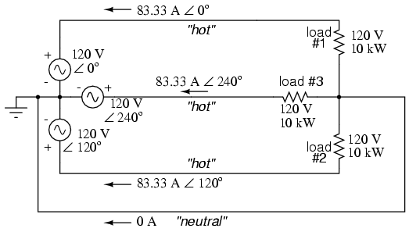
SPICE circuit annotated with simulation results: Three 3-Φ loads phased at 120º.
So long as the loads remain balanced (equal resistance, equal currents), the neutral wire will not have to carry any current at all. It is there just in case one or more load resistors should fail open (or be shut off through a disconnecting switch).
This circuit we've been analyzing with three voltage sources is called a polyphase circuit. The prefix “poly” simply means “more than one,” as in “polytheism” (belief in more than one deity), “polygon” (a geometrical shape made of multiple line segments: for example, pentagon and hexagon), and “polyatomic” (a substance composed of multiple types of atoms). Since the voltage sources are all at different phase angles (in this case, three different phase angles), this is a “polyphase” circuit. More specifically, it is a three-phase circuit, the kind used predominantly in large power distribution systems.
Let's survey the advantages of a three-phase power system over a single-phase system of equivalent load voltage and power capacity. A single-phase system with three loads connected directly in parallel would have a very high total current (83.33 times 3, or 250 amps. (Figure below)
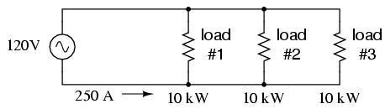
For comparison, three 10 Kw loads on a 120 Vac system draw 250 A.
This would necessitate 3/0 gage copper wire (very large!), at about 510 pounds per thousand feet, and with a considerable price tag attached. If the distance from source to load was 1000 feet, we would need over a half-ton of copper wire to do the job. On the other hand, we could build a split-phase system with two 15 kW, 120 volt loads. (Figure below)
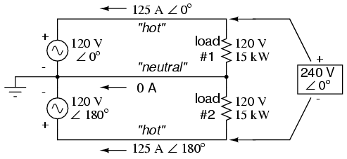
Split phase system draws half the current of 125 A at 240 Vac compared to 120 Vac system.
Our current is half of what it was with the simple parallel circuit, which is a great improvement. We could get away with using number 2 gage copper wire at a total mass of about 600 pounds, figuring about 200 pounds per thousand feet with three runs of 1000 feet each between source and loads. However, we also have to consider the increased safety hazard of having 240 volts present in the system, even though each load only receives 120 volts. Overall, there is greater potential for dangerous electric shock to occur.
When we contrast these two examples against our three-phase system (Figure above), the advantages are quite clear. First, the conductor currents are quite a bit less (83.33 amps versus 125 or 250 amps), permitting the use of much thinner and lighter wire. We can use number 4 gage wire at about 125 pounds per thousand feet, which will total 500 pounds (four runs of 1000 feet each) for our example circuit. This represents a significant cost savings over the split-phase system, with the additional benefit that the maximum voltage in the system is lower (208 versus 240).
One question remains to be answered: how in the world do we get three AC voltage sources whose phase angles are exactly 120º apart? Obviously we can't center-tap a transformer or alternator winding like we did in the split-phase system, since that can only give us voltage waveforms that are either in phase or 180º out of phase. Perhaps we could figure out some way to use capacitors and inductors to create phase shifts of 120º, but then those phase shifts would depend on the phase angles of our load impedances as well (substituting a capacitive or inductive load for a resistive load would change everything!).
The best way to get the phase shifts we're looking for is to generate it at the source: construct the AC generator (alternator) providing the power in such a way that the rotating magnetic field passes by three sets of wire windings, each set spaced 120º apart around the circumference of the machine as in Figure below.
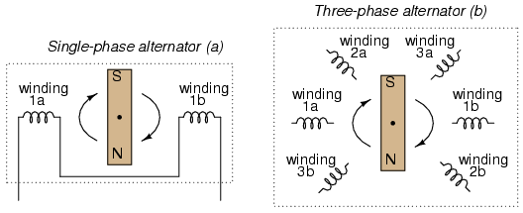
(a) Single-phase alternator, (b) Three-phase alternator.
Together, the six “pole” windings of a three-phase alternator are connected to comprise three winding pairs, each pair producing AC voltage with a phase angle 120º shifted from either of the other two winding pairs. The interconnections between pairs of windings (as shown for the single-phase alternator: the jumper wire between windings 1a and 1b) have been omitted from the three-phase alternator drawing for simplicity.
In our example circuit, we showed the three voltage sources connected together in a “Y” configuration (sometimes called the “star” configuration), with one lead of each source tied to a common point (the node where we attached the “neutral” conductor). The common way to depict this connection scheme is to draw the windings in the shape of a “Y” like Figure below.
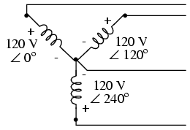
Alternator "Y" configuration.
The “Y” configuration is not the only option open to us, but it is probably the easiest to understand at first. More to come on this subject later in the chapter.
- REVIEW:
- A single-phase power system is one where there is only one AC voltage source (one source voltage waveform).
- A split-phase power system is one where there are two voltage sources, 180º phase-shifted from each other, powering a two series-connected loads. The advantage of this is the ability to have lower conductor currents while maintaining low load voltages for safety reasons.
- A polyphase power system uses multiple voltage sources at different phase angles from each other (many “phases” of voltage waveforms at work). A polyphase power system can deliver more power at less voltage with smaller-gage conductors than single- or split-phase systems.
- The phase-shifted voltage sources necessary for a polyphase power system are created in alternators with multiple sets of wire windings. These winding sets are spaced around the circumference of the rotor's rotation at the desired angle(s).

Phase rotation

Let's take the three-phase alternator design laid out earlier (Figure below) and watch what happens as the magnet rotates.
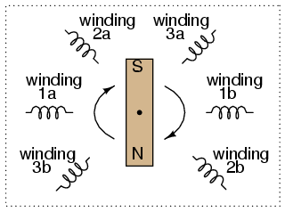
Three-phase alternator
The phase angle shift of 120º is a function of the actual rotational angle shift of the three pairs of windings (Figure below). If the magnet is rotating clockwise, winding 3 will generate its peak instantaneous voltage exactly 120º (of alternator shaft rotation) after winding 2, which will hits its peak 120ºafter winding 1. The magnet passes by each pole pair at different positions in the rotational movement of the shaft. Where we decide to place the windings will dictate the amount of phase shift between the windings' AC voltage waveforms. If we make winding 1 our “reference” voltage source for phase angle (0º), then winding 2 will have a phase angle of -120º (120º lagging, or 240º leading) and winding 3 an angle of -240º (or 120º leading).
This sequence of phase shifts has a definite order. For clockwise rotation of the shaft, the order is 1-2-3 (winding 1 peaks first, them winding 2, then winding 3). This order keeps repeating itself as long as we continue to rotate the alternator's shaft. (Figure below)
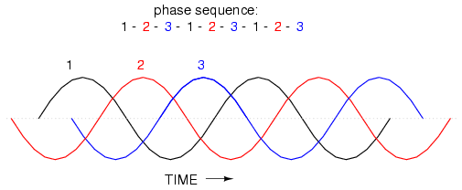
Clockwise rotation phase sequence: 1-2-3.
However, if we reverse the rotation of the alternator's shaft (turn it counter-clockwise), the magnet will pass by the pole pairs in the opposite sequence. Instead of 1-2-3, we'll have 3-2-1. Now, winding 2's waveform will be leading 120º ahead of 1 instead of lagging, and 3 will be another 120º ahead of 2. (Figure below)
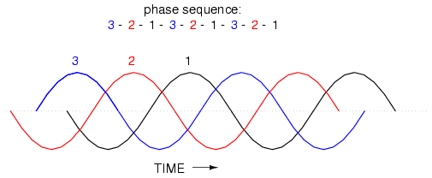
Counterclockwise rotation phase sequence: 3-2-1.
The order of voltage waveform sequences in a polyphase system is called phase rotation or phase sequence. If we're using a polyphase voltage source to power resistive loads, phase rotation will make no difference at all. Whether 1-2-3 or 3-2-1, the voltage and current magnitudes will all be the same. There are some applications of three-phase power, as we will see shortly, that depend on having phase rotation being one way or the other. Since voltmeters and ammeters would be useless in telling us what the phase rotation of an operating power system is, we need to have some other kind of instrument capable of doing the job.
One ingenious circuit design uses a capacitor to introduce a phase shift between voltage and current, which is then used to detect the sequence by way of comparison between the brightness of two indicator lamps in Figure below.
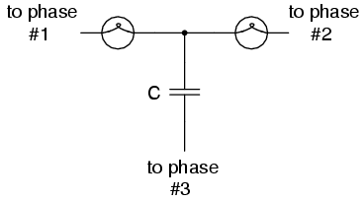
Phase sequence detector compares brightness of two lamps.
The two lamps are of equal filament resistance and wattage. The capacitor is sized to have approximately the same amount of reactance at system frequency as each lamp's resistance. If the capacitor were to be replaced by a resistor of equal value to the lamps' resistance, the two lamps would glow at equal brightness, the circuit being balanced. However, the capacitor introduces a phase shift between voltage and current in the third leg of the circuit equal to 90º. This phase shift, greater than 0º but less than 120º, skews the voltage and current values across the two lamps according to their phase shifts relative to phase 3. The following SPICE analysis demonstrates what will happen: (Figure below), "phase rotation detector -- sequence = v1-v2-v3"
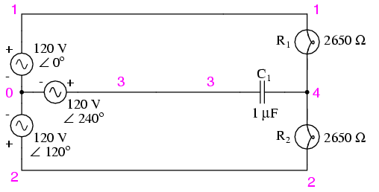
SPICE circuit for phase sequence detector.
phase rotation detector -- sequence = v1-v2-v3
v1 1 0 ac 120 0 sin
v2 2 0 ac 120 120 sin
v3 3 0 ac 120 240 sin
r1 1 4 2650
r2 2 4 2650
c1 3 4 1u
.ac lin 1 60 60
.print ac v(1,4) v(2,4) v(3,4)
.end

freq v(1,4) v(2,4) v(3,4)
6.000E+01 4.810E+01 1.795E+02 1.610E+02
The resulting phase shift from the capacitor causes the voltage across phase 1 lamp (between nodes 1 and 4) to fall to 48.1 volts and the voltage across phase 2 lamp (between nodes 2 and 4) to rise to 179.5 volts, making the first lamp dim and the second lamp bright. Just the opposite will happen if the phase sequence is reversed: "phase rotation detector -- sequence = v3-v2-v1 "
phase rotation detector -- sequence = v3-v2-v1
v1 1 0 ac 120 240 sin
v2 2 0 ac 120 120 sin
v3 3 0 ac 120 0 sin
r1 1 4 2650
r2 2 4 2650
c1 3 4 1u
.ac lin 1 60 60
.print ac v(1,4) v(2,4) v(3,4)
.end

freq v(1,4) v(2,4) v(3,4)
6.000E+01 1.795E+02 4.810E+01 1.610E+02
Here,("phase rotation detector -- sequence = v3-v2-v1") the first lamp receives 179.5 volts while the second receives only 48.1 volts.
We've investigated how phase rotation is produced (the order in which pole pairs get passed by the alternator's rotating magnet) and how it can be changed by reversing the alternator's shaft rotation. However, reversal of the alternator's shaft rotation is not usually an option open to an end-user of electrical power supplied by a nationwide grid (“the” alternator actually being the combined total of all alternators in all power plants feeding the grid). There is a much easier way to reverse phase sequence than reversing alternator rotation: just exchange any two of the three “hot” wires going to a three-phase load.
This trick makes more sense if we take another look at a running phase sequence of a three-phase voltage source:
1-2-3 rotation: 1-2-3-1-2-3-1-2-3-1-2-3-1-2-3 . . .
3-2-1 rotation: 3-2-1-3-2-1-3-2-1-3-2-1-3-2-1 . . .
What is commonly designated as a “1-2-3” phase rotation could just as well be called “2-3-1” or “3-1-2,” going from left to right in the number string above. Likewise, the opposite rotation (3-2-1) could just as easily be called “2-1-3” or “1-3-2.”
Starting out with a phase rotation of 3-2-1, we can try all the possibilities for swapping any two of the wires at a time and see what happens to the resulting sequence in Figure below.
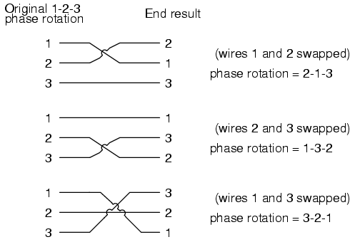
All possibilities of swapping any two wires.
No matter which pair of “hot” wires out of the three we choose to swap, the phase rotation ends up being reversed (1-2-3 gets changed to 2-1-3, 1-3-2 or 3-2-1, all equivalent).
- REVIEW:
- Phase rotation, or phase sequence, is the order in which the voltage waveforms of a polyphase AC source reach their respective peaks. For a three-phase system, there are only two possible phase sequences: 1-2-3 and 3-2-1, corresponding to the two possible directions of alternator rotation.
- Phase rotation has no impact on resistive loads, but it will have impact on unbalanced reactive loads, as shown in the operation of a phase rotation detector circuit.
- Phase rotation can be reversed by swapping any two of the three “hot” leads supplying three-phase power to a three-phase load.

